**Here are the steps to install and configure notebook server: -**

* Step 1. download and install miniconda

https://repo.anaconda.com/miniconda/Miniconda3-latest-Linux-x86_64.sh

bash Miniconda3-latest-Linux-x86_64.sh

and follow steps to install Miniconda

* Step 2 Install notebook server and ipywidgets

restart terminal

conda update conda

conda install notebook==5.7.8

conda install ipywidgets==7.4.2

* Step 3 Configure notebook server

jupyter notebook --generate-config

jupyter --config-dir

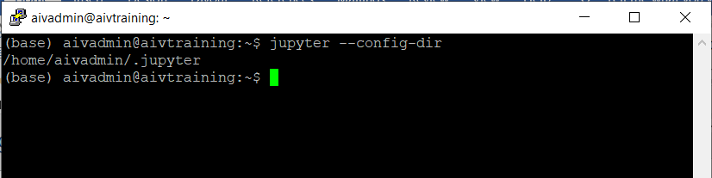

nano /home/aivadmin/.jupyter/jupyter_notebook_config.py and set below

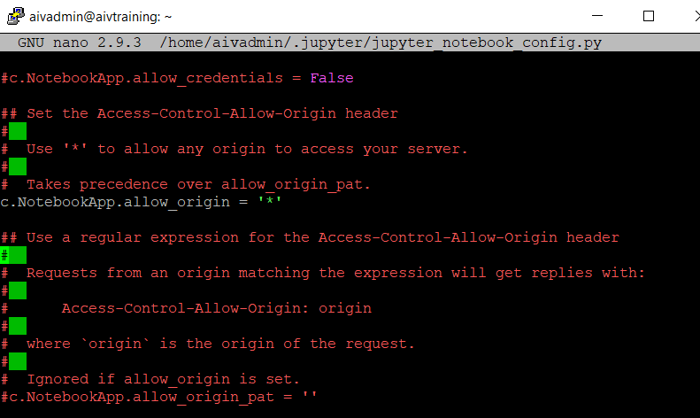

c.NotebookApp.ip = '0.0.0.0'

c.NotebookApp.token = ''

c.NotebookApp.password = ''

c.NotebookApp.allow_origin = '*'

c.NotebookApp.disable_check_xsrf = True

c.NotebookApp.notebook_dir = '/opt/notebook_dir/' (Make sure this directory is available)

c.NotebookApp.open_browser = False

* Step 4 run jupyter notebook server

Jupyter notebook

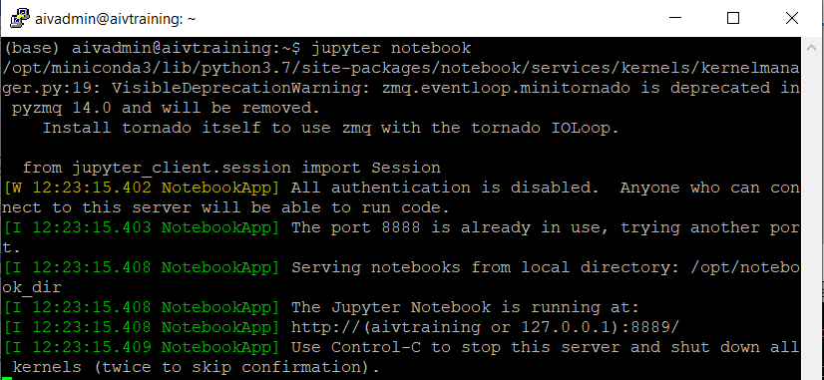

In your case jupyter will run in port 8888.

Make sure you can access notebook server at 127.0.0.1:8888/ port

* Step 5 Setup r kernel (Only if required r script support)

conda install -c conda-forge folium

conda install -c r r-essentials

conda install r-irkernel

R

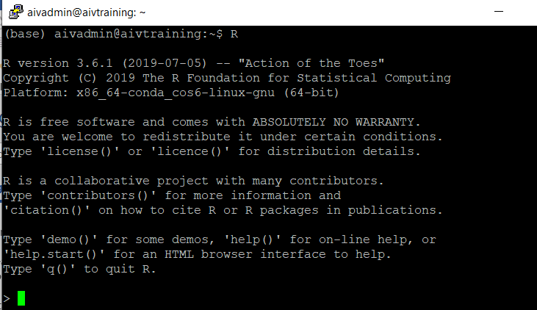

R prompt

q()

* Step 6 run notebook service in background

nohup jupyter notebook --config=/home/aivadmin/.jupyter/jupyter_notebook_config.py